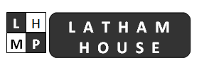

STATEMENT

We are disappointed with the findings of the Care Quality Commission (CQC) inspection. As a Practice we have accepted the report and are taking its report seriously. We are committed to providing good quality care for our patients and are responding to each of the CQC recommendations for improvement.

The response to the CQC inspection was immediate. We have an action plan in place and we are working collaboratively with a team from the Royal College of General Practitioners. The Practice is confident that we will be able to assure the CQC on all aspects of the inspection.

Our primary focus remains with our patients and the Practice has a lot to be proud of. We continue to provide effective and caring services which the CQC has acknowledged, rating these services as ‘good’.

We are confident that we will be able to make the required changes to improve our services as we aim for a ‘good’ rating across the board. We would like to reassure patients that there will be no disruption to ongoing patient care.

Any Media contact should be made through LHMP.Media@nhs.net

