- Early Help
Direct referral is through Leicestershire County Council website search bar Early help or https://recources.leicestershire.gov.uk./education-and-children/child-protection-and-safeguarding/early-help

Advice line and information about walking in centres
Telephone: 0116 305 8727
📧 Email: earlyhelpreferrals@leics.gov.uk – for families or HCPs

Walk in centre - our nearest: Melton District Sure Start Centre, Sysonby street, LE13 0LP; Fairmead Children's Centre 64 Drummond Walk, Melton LE13 1JF.

For Melton info ring: 01664 502 402. Ask for Early Help.

- Other resources for children

Chathealth - texting service for teens and children, by school nurses -
Telephone: 07520 615 387 (county)
Mon-Friday 9-5pm, aim to respond within 24hrs
Health for teen’s website - information website, https://www.healthforteens.co.uk
Young minds telephone advice line for children, parents and carers –
Telephone: 0808 802 5544 (Monday-Friday)
https://youngminds.org.uk
B-eat - information about eating disorders; https://www.beateatingdisorders.org.uk

Patients can self-refer to the following free services:

- Let’s Talk-Wellbeing
Provides a variety of counselling services and treatments for mild to moderate common mental health problems.
Please complete the online self-referral form at: www.iaptportal.co.uk/ltw.html or
Telephone 0115 876 0157

- Physiotherapy Direct Service (community physio 16+)
Provides telephone consultations, advice and exercises, and face to face appointments.
Ask a member of staff for a ‘Physiotherapy Direct Service’ card.
Telephone 0300 300 0046

- Turning Point
Offers a range of services providing individual support to help address drug or alcohol issues, mental health concerns, learning disabilities, or employment solutions.
Telephone 0330 303 6000 or
📧 Email LLreferrals@turning-point.co.uk

- Sexual Health Services (Family planning and STI check)
Haymarket Health, 1st Floor, Haymarket Shopping Centre, LE1 3YT.
Offers a drop in clinic on a Wednesday evening. For more information call:
Telephone: 0300 124 0102

- BPAS (British Pregnancy Advisory Service)
The UK’s leading abortion care service, BPAS are an independent healthcare charity who advocate and care for women and couples who decide to end a pregnancy.
For more info and additional services visit:
https://www.bpas.org/ or
Telephone: 08457 30 40 30

- Weight Management
Provides weight management support, advice and services.
Call for more info or LEAP and Weight Watchers vouchers.
Telephone 0116 222 7192 or 0116 222 7154
- Support for Carers
Provides independent information and support to carers in Leicestershire, aiming to help you look after your own health and wellbeing, as well as the person you care for.
Visit the websites below for more info:
Leicestershire County Council: https://www.leicestershire.gov.uk/adult-social-care-and-health/looking-after-someone
VASL: https://vasl.org.uk/

- Me and My Learning
Offers various support for local Melton Borough residents with the aim of ‘supporting you to become more independent whether that be financially, socially or digitally’.
Please visit their website for more info:
http://www.melton.gov.uk/meandmylearning/
Telephone: 01664 502342
📧 Email: meandmylearning@melton.gov.uk

- Early Help Service
Early help is a Leicestershire County Council service that aims to work with children, young people and families who are experiencing difficulties.
Visit the Leicestershire County Council website for more info:
https://www.leicestershire.gov.uk/education-and-children/social-care-and-supporting-families/early-help-for-children-and-young-people or
Telephone: 0116 305 8727

- Maternity Service: St Mary’s Birth Centre, Melton Mowbray
Provides care for low risk pregnant women and their families before, during and after birth.
Visit their website for more info: http://www.leicestermaternity.nhs.uk/maternity-services/where-are-we/st-marys-birth-centre/ or
Telephone: 01664 854 854

- Podiatry (foot and lower limb care)
The Leicestershire Partnership NHS Trust offers a complete range of foot and lower limb care. Ask a member of staff for a self-referral form.
Telephone 0116 225 5118
📧 Email podiatryappointments@leicspart.nhs.uk
- Alzheimer Society Dementia Support Service
The service is suitable for a broad range of pts - from those who are simply concerned about their own or a family member’s memory to those who have had a formal diagnosis of dementia (regardless of type).
The service is comprehensive in that it offers pretty much all the information anyone would need. The issues discussed with the pt/family are very much the same as those that would be discussed for advanced care planning so it helps us because the pt/family would have had time to think about this before our team do their work.

Referral can be via GP/other health worker
SELF-REFERRAL - Tel 0116 231 6921
Via PRISM or via First connect

- CRUSE (Bereavement Counselling Service)
Provides support, advice and information to anyone who has had someone close to them dies.

http://www.cruse.org.uk
📧 Email: leicester@cruse.org.uk
Telephone: 0116 288 4119

- First Contact Plus
First Contact Plus is an online tool that helps adults in Leicestershire find information about a range of services all in one place.
The initiative allows residents who require help with one or a number of issues to access a catalogue of information, advice, help and support. Information and resources on housing, health, living independently, money advice, work, security and other topics that assist the county’s residents can be found on this site:

http://www.firstcontactplus.org.uk/

📧 Email: firstcontact@leics.gov.uk
Telephone: 0116 305 4286

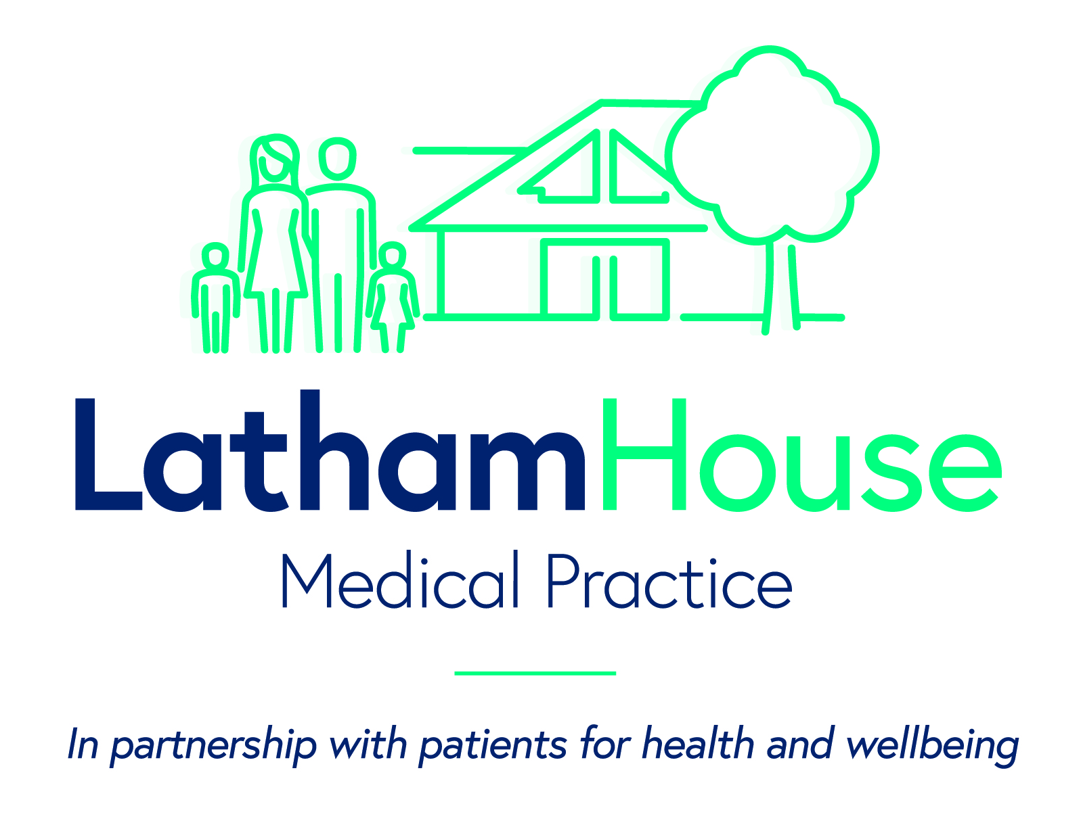
Patient Self Referrals

Latham House Medical Practice. Sage Cross Street, Melton Mowbray, Leicestershire. LE13 1NX.
Telephone: 01664 503000

