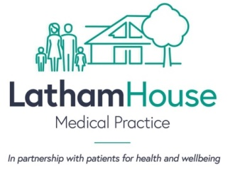
As a patient at Latham House you have the opportunity to register for online services known as SystmOnline. SystmOnline allows you to order repeat medication and book routine appointments online. You are also able to view certain aspect of your medical records if you are 16 or over. Please complete the following application form which will allow us to set your online access. You will need to provide a form of photo ID, or if this is not available to you, and our staff know you then they can now vouch for you. Further information is available at https://www.lhmp.co.uk/online-facilities/

Who can apply?
- Patients aged 16 and above (For children under the age of 16, parents can access appointments and prescriptions only)

What is needed?
- Photo ID or a member of staff to vouch for you (due to the circumstances at present, we will accept a photo attachment sent with this form).

SystmOnline:

I have photo ID with me today
ID has been checked or photo copied for online registration

A staff member can vouch for me (staff name: ________________________________________)

Online registered (your registration details will be emailed/text to you)

Access to medical records:

By requesting to view your medical records online, there may be occasions you will see clinical documents such as hospital letters and/or test results, which your doctor has not yet discussed with you.

I would like to request to view my medical records online

Patient Details:

Name: Date of birth: Gender:

Telephone:

Email:

I am the parent/guardian of the patient named below, aged under 16, and request online access for appointments and prescriptions

Child Name: Date of birth:

Telephone:

Email:
FOR STAFF USE

Registration completed: Access to medical records granted:

