**Welcome to Latham House Medical Practice**



**In this Practice Booklet**

* **Welcome.**
* **Getting in Touch.**
* **Local NHS Walk in service.**
* **About Latham House Medical Practice.**
* **How to get the help you need.**

**Stay Connected**

**Town Centre Practice**

01664 503000

**Asfordby Surgery**

01664 503006

**Website**

www.lhmp.co.uk

**Email**

llricb-llr.general.enquiries@nhs.net

**24hr cancellation line**

01664 503027

**Out of hours: 111**



Follow us on Twitter  
@LathamHouseMP

  
Follow us on Facebook  
@Lathamhousemedicalpractice

**Welcome to Latham House Medical Practice**

Latham House Medical Practice has been serving the market town of Melton Mowbray and the surrounding area for over 90 years and we aim to provide professional, accessible, high quality general practice healthcare services that involves patients in decisions and choice in their care.

We are one of the largest General Practices in the UK and this scale enables us to provide a wide variety of services to our patients from a wide range of clinicians at our premises as well as play our role as a training Academy. We are proud of this unique status and can offer some surgical procedures locally, saving our patients a trip to the hospital.

We encourage our clinicians to have specialist areas of interest and we advocate our doctors holding registered lists so that patients can forge long-lasting relationships with the doctor of their choice.

Latham House Medical Practice is also proud to work as part of the Melton, Syston and the Vale Primary Care Network (MSV PCN)

We also operate a smaller branch surgery in the village of Asfordby.

We also offer a number of ways for getting in touch for patient convenience. Patients can get in touch online, on email or by phone and App.  We always provide a consultation with the most appropriate clinician depending on your needs when you contact us.

* The Practice does not de-register patients if you have not been seen in the Practice for a few years.

This booklet contains information about the services at the Practice and we hope you will find it useful. You can also find updated information at [www.lhmp.co.uk](http://www.lhmp.co.uk/)

We are a friendly, caring team and we look forward to supporting your wellbeing.

The Latham House Team

**Practice** **Information**

Latham House Medical Practice

Sage Cross Street, Melton Mowbray, Leicestershire, LE13 1NX

Tel: 01664 503000

Asfordby Branch Surgery

Regency Road, Asfordby, Leicestershire, LE14 3YL

Tel: 01664 503006

**24hr cancellation line: 01664 503027**



Email: [llricb-llr.general.enquiries@nhs.net](mailto:llricb-llr.general.enquiries@nhs.net)

Online: Engage Consult at www.lhmp.co.uk



OUT OF HOURS TEL NUMBER: **111**

If it’s not an emergency but you need medical help fast or want to call the GP Out of Hours service call 111 for free**.**

**Please call 999 if the concern is life threatening.**

**Latham House Medical Practice**

**Monday** 08:00 - 18:30pm

**Tuesday** 08:00 - 18:30pm

**Wednesday** 08:00 - 18:30pm

**Thursday** 08:00 - 18:30pm

**Friday** 08:00 - 18:30pm

**Saturday** CLOSED

**Sunday** CLOSED

**Opening hours**

**Asfordby Surgery**

08:30am -11:30am

08:30am -11:30am

08:30am -11:30am

Alliance Surgery service

08:30am -11:30am

Booked appointments.

CLOSED

**Ways to get in touch.**

* **Call us on** **01664 503000.**

Please be aware you will be asked some questions as part of your contact with us.

**24hr cancellation line: 01664 503027**

* **Online**

The Engage Consult service is for **non-Urgent** medical queries or any requests. **Engage Consult** is available at [**www.lhmp.co.uk**](http://www.lhmp.co.uk/)and we respond to all contacts on the same day if received before 2pm.

* **Email**

General Enquiries at: [llricb-llr.general.enquiries@nhs.net](mailto:llricb-llr.general.enquiries@nhs.net)

Prescriptions at: [lhmp.prescription@nhs.net](mailto:lhmp.prescription@nhs.net)

Online service support at: [lhmp.computer@nhs.net](mailto:lhmp.computer@nhs.net)

Hard of hearing support at: Hardofhearing.support@nhs.net

* **Via the App**

You can manage your own repeat prescriptions, appointments and view your medical records on **the AirMid or NHS app**. Visit our website for online services.

* **Find out more.**

Please visit our website as a source for information. A lot of your questions may be answered in our resources. [**www.lhmp.co.uk**](http://www.lhmp.co.uk/)



**Local Urgent Care Support**

**Loughborough NHS Walk-In Centre**

Pinfold Gate

Loughborough

LE11 1BE

Opening Hours:

Open 24 hours a day

*Walk in and Bookable via 111*

**Melton Mowbray Urgent Care Centre**

Melton Mowbray Hospital

Thorpe Road

Melton Mowbray

LE13 1SJ

*Bookable via 111*

*Opening Hours:*

*Monday to Friday – 06:30pm to 09:00pm*

*Sat/Sun/Bank Holiday – 09:00am to 07:00pm*

**Oakham Urgent Care Centre**

Rutland Memorial Hospital

Cold Overton Road

Oakham. LE15 6NT

Opening Hours:

Monday to Friday – 05:00pm to 09:00pm

Sat/Sun/Bank Holidays – 09:00am – 07:00pm

*Bookable via 111*

**Catchment Area**

Areas covered by Latham House Medical Practice

Ab Kettleby

Wymondham

Holwell

Hose

John O’Gaunt

Kirby Bellars

Lowesby

Marefield

Nether Broughton

Old Dalby

Owston

Pickwell

Ragdale

Rotherby

Saltby

Saxby

Saxelby

Scalford

Shoby

Six Hills

Somerby

South Croxton

Sproxton

Stapleford

Stathern

Stonesby

Teigh

Thorpe Arnold

Thorpe Satchville

Thrussington

Twyford

Waltham

Wartnaby

Welby

Whissendine

Wycomb

Wyfordby

Asfordby

Asfordby Hill

Ashby Folville

Ashwell

Barsby

Bescaby

Branston

Brentingby

Brooksby

Buckminster

Burrough on the Hill

Burton Lazars

Chadwell

Cold Overton

Coston

Eastwell

*We no longer accept patients from Upper Broughton

Eaton

Edmonthorpe

Freeby

Frisby-on-the-Wreake

Gaddesby

Garthorpe

Goadby Marwood

Great Dalby

**East Leicestershire & Rutland ICB:**

Leicestershire County Council

Room G30, Pen Lloyd Building

County Hall, Glenfield.

LE3 8TB

0116 295 3405

Grimston

Harby

Hoby

Langham

Little Dalby

Long Clawson

**Our Clinical Team**

**General Practitioners:**

**Partners**

Dr P Atkinson – *MBChB MRCGP MSc (CEO, Caldicott Guardian)*

Dr G Dabali – *MD MBBS*

Dr G Hirani – *MB ChB MRCGP DFFP*

Dr S Hirani – *MB ChB DRCOG MRCGP DPD*

Dr E Loughridge – *BMedSci BM BS DRCOG  MRCGP*PgDip ENT

Dr R Modi – *MBBS MRCGP BSc (Hons)*

Dr S Paliath – *MBBS MRCGP DGM DFSRH*

Dr A Pearce-Smith – *BMBS MRCGP*

Dr M Riley – *MBChB MRCGP*

Dr R Singh – *MBBS MRCGP*

**Salaried GPs**

Dr B Miri - *MBBS FRCS MRCGP*

Dr M Raja- *MBChB BSc (Hons) MRCP (2012) and MRCGP (2015) DRCOG*

Dr M Reason-*MBChB MRCGP*

Dr K Sethi- *MBChB MRCGP MRCPCH DRCOG*

Dr M Smith-*MBChB MRCGP*

Dr J Wa- *BMedSci BMBS MRCGP*

Dr O Iwanskyj -MRCGP, DRCOG, DFSRH

Dr G Pettifer- MBChB (Hons), BSc (Hons), DRCOG, PGCert, DGM

Dr P Finn-MBBS DFFP DRCOG DPM MRCGP

Dr S Waddingham -MRCGP BMSc MBBS

Dr A Saxena- MRCGP MBBS

Dr K Virag

**Head of Clinical Services:** Kerry E

**Management:** Paul Crosbie – *Executive Manager /* Tracy P – *PCN Manager*

*For a full list of our clinical team please visit https://www.lhmp.co.uk/the-practice/meet-the-team/*

**Practice Charter**

* LHMP is committed to continuous professional medical care of its patients.
* Patients have the right to change their GP.
* Patients have the right to confidentiality from all members of the Practice team.
* Patients have the right to be involved in decisions that affect their health.
* Patients have the right to information about their illness and its treatment.
* The Practice will inform patients of services available to them by means of a Practice booklet, via our social media pages and on the Latham House website [www.lhmp.co.uk](http://www.lhmp.co.uk/)
* The Practice offers advice and seeks to inform patients of steps they can take to promote good health and avoid illness.
* Patients will be triaged, and urgent medical conditions will be prioritized and offered same day appointment as soon as possible.
* Doctors and Nurses will aim to run their clinics to time. Where there is a delay, we will endeavor to contact the patient to offer an explanation. Patients will be invited to rebook their appointment.
* Patients will be referred for a further opinion, when their GP thinks it necessary, and will be offered a choice of secondary care provision via electronic referral system.
* Patients may choose whether to take part in research or training.
* Repeat prescriptions requested will be made available to the nominated Pharmacy within 48 working hours. The Practice cannot be held responsible for the pharmacy processing timescales.
* All Doctors and staff are committed to continuing education and training in order to deliver the highest standard of medical care.

**Patient Responsibilities**

* Patients should show the same commitment to improving their own and their family’s health as they expect from their doctor.
* Please use the Practice facilities and services in a responsible manner.
* Appointments
  + Please be punctual for appointments.
  + Routine GP appointments are scheduled for up to 10 minutes and GPs are committed to maintaining their clinic timings for the benefit of all patients.
  + Each appointment is for one person only and where possible, one problem. This ensures the patient receives thorough information for each concern. If you have a few issues to discuss, we might offer you a double appointment to cover all topics or concerns.
  + Please notify us as soon as possible if you are unable to keep an appointment. Use our 24-hour cancellation line to keep us informed. By notifying us in good time, you enable us to offer the appointment to other patients.
* The home visiting service is for patients whose medical conditions make it impossible for them to attend surgery. This information will be updated on the patient medical notes.
* It is the patient's responsibility to effectively schedule and order their repeat prescriptions in good time (advised 10 days before you are due to run out of medication). Repeat prescriptions should be requested routinely through the Air mid app or NHS app. Please make an appointment with your own Doctor when requested, to review your medication.
* To make the most of our services, patients are advised to sign up to online services. Through the Airmid or NHS app, patients can make routine appointments and order authorised repeat prescriptions. Please use these services responsibly.
* It is the patient’s responsibility to ensure information held by the Practice is up to date including mobile phone numbers and home addresses.

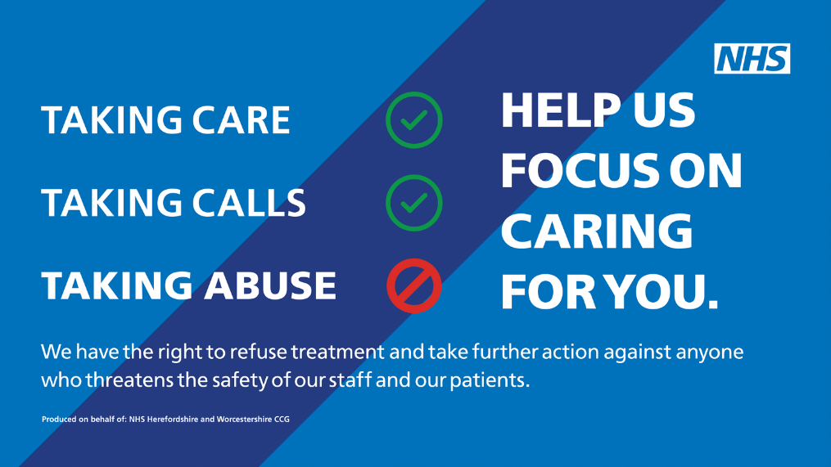#BEKIND: Please extend the same courtesy to us and our staff that we extend to you. Along with other NHS organisations we have a ZERO tolerance Policy. If a patient is physically violent or uses threatening behavior towards a doctor, or other member of the Practice staff, we do have the right to remove them from the Practice list. Shouting and swearing at Practice staff will not be tolerated.



**SMS Text Communications**

The Practice utilises SMS text messaging as a communication route with patients for greater patient convenience.

This service includes a text appointment reminder service, blood test results and NHS campaign information (stop smoking, flu).

Please see a receptionist if you wish to opt OUT of this service.

**How to get the help you need**

**Reception Staff**

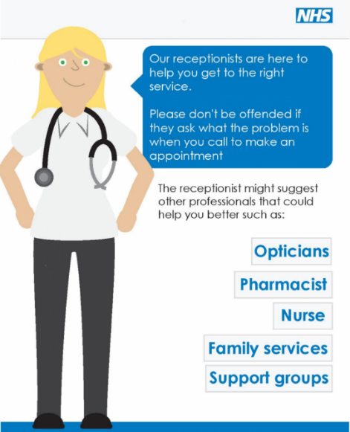Our receptionists are available to help you between 08:00am and 06:30pm Monday to Friday.

When telephoning for medical attention our Reception Staff will ask for a few details. The Doctors have asked them to make these enquiries so that they can help you in the most appropriate way.

Our Reception Staff have undertaken special training and always respect patient confidentiality.

Please share as much information as you can to enable our team to help you find the most appropriate care for your need.

**Urgent matters - IAC**

The immediate access clinic is available for medical problems that cannot wait for a routine appointment or for the significant worsening of an existing problem.

If you require a ‘same day’ appointment for a concern that cannot wait, please telephone us on 01664 503000. Attendance to IAC is by appointment only, we do not offer a sit and wait service.

You will be offered a same day telephone triage appointment with the Immediate Access Nurse Practitioner. This enables us to triage and prioritise the cases that we receive every day.

The IAC Nurse Practitioner will aim to support your request for medical intervention on this call. You will be invited to attend the Practice on the same day if they feel there is a clinical need to see you.

Should you need to see a GP, this will be arranged for you according to your clinical requirements, either urgently on the same day or in a routine appointment.

**Minor Treatments**

Minor Treatment Unit:  Our Minor Treatment Unit is open from 08:00am to 18:30pm and is staffed by trained Clinicians who will offer treatment, help and advice. Should you think you need to be seen following a minor accident that you cannot treat yourself, you can attend in person, or telephone 01664 503000 to make an appointment. The Minor Treatment Unit is equipped to a very high standard, making the investigation and treatment of patients easier within our premises than in your own home.

**Routine Appointments**

Routine appointments can be booked through Engage Consult, on the Airmid or NHS app or on email at [llricb-llr.general.enquiries@nhs.net](mailto:llricb-llr.general.enquiries@nhs.net) or by speaking to the reception team. We try to ensure that, wherever possible, you will see your registered GP for continuity of care.

**Repeat Prescriptions**

The Prescriptions team can be contacted direct by phoning our main number or by email at [**lhmp.prescription@nhs.net**](mailto:lhmp.prescription@nhs.net) **.**

The Practice uses the electronic prescription service (EPS), which enables patients to have their repeat prescription requests managed online and set for collection from your nominated Pharmacy.

This will mean you can order your request medication online and do not have to come into the Practice to collect the prescription.

You should request your repeat medications when you have a week to 10 day’s supply left. The Practice process requests within 48 working hours, but your elected pharmacy may take considerably longer to prepare your medication. Only tick only the items you require on your repeat prescription from. Paper prescriptions can be posted in the prescriptions post box in the main entrance of the Practice.

For items not on repeat prescription, you will need to speak to our prescriptions department who will arrange for you to speak with either one of our pharmacists or your registered Doctor. If you have any queries, please speak to the prescriptions department.

**Other Clinics available to our Patients**

* Family planning
* Coils
* Hypertension
* Liquid Nitrogen
* Coronary heart disease
* Child health surveillance
* Travel clinic
* Peripheral vascular disease
* Cardiovascular disease
* Chronic kidney disease
* 24-hour Blood Pressure Management
* CHAT Clinic (confidential advice for teenagers)
* Hypertension
* Liquid Nitrogen
* Coronary heart disease
* Child health surveillance
* Travel clinic
* Peripheral vascular disease
* Cardiovascular disease
* Chronic kidney disease
* 24-hour Blood Pressure Management
* Diabetes
* Minor Surgery
* Asthma
* Cervical Screening
* NHS Health Checks
* Ear Syringing
* Simple wound clinics
* Mental Health Nurse
* NHS Digital Weight Management
* Family planning
* Coils



**Primary healthcare team**

Leicester, Leicestershire and Rutland Integrated Care Board (LLRICB) is responsible for planning and overseeing healthcare services of our patients.

The Practice is supported by a wide range of other health professionals in the community. In some instances, your GP might need to refer you to them, and in other circumstances you can refer yourself, please talk to a member of staff if you need advice on how to contact:

* Health Visitors
* District Nurses
* Community Psychiatric Nurses
* Macmillan Nurse
* Physiotherapist
* Please visit <https://www.lhmp.co.uk/patient-self-referral/> or ask reception for more information.

**Accessibility**

We have implemented many improvements to ensure the Practice is as easily accessible and user-friendly for all of our patients with access needs.

We have wide entrances, walkways, ramps and public lifts to support wheelchair-bound patients. A wheelchair is also available for those having trouble walking - this can be obtained through our Reception Staff.

* We have designated disabled parking spaces in the patient car park.
* Support is available to help the hard of hearing have clearer conversations.
* Surgery rooms located on the first floor are accessible by using the lift.
* We provide chairs with arms in our waiting rooms.
* Provision of information in large type font.
* Access to braille translation services.
* Directional signs in colors and shapes to guide our around out main premises.
* Our website is complaint with the accessibility standard.
* There are also disabled toilet facilities throughout the surgery.
* A room is available on request to discuss matters in private.

If you experience any problems with your physical needs not being met, please speak to a member of Staff who will do their utmost to assist you. Should you find our facilities do not meet your requirements, please give us your feedback

**Language**

The Practice can offer a translator service for patients whose first language is not English. Please inform the Reception Team if you require a translator for your appointment with any Clinicians so your records can be updated.

If you have any access problems with our services, either physically or how we communicate with you, please let us know so that your access needs can be addressed.

**Useful Information**

**Accessing your results:** Patients can access their results of recent tests through the AirMid or NHS app.

Alternatively, please telephone or email to obtain the results of any tests requested by the Doctor or Nurse. It is the responsibility of all patients to contact the surgery for the results of any tests we have performed.

**Access to medical information:** Patients now have access to their medical history when viewing their records online. This was implemented as standard by the NHS is 2022/23. Should you require access to your medical information, you can either do this online or make a request in writing. Please note that depending on the type of information required there might be a charge which needs to be met prior to releasing this information. Our staff will be able to offer further help and advice to you. Visit our website for more information or alternatively there is a standard form available at Main Reception.

**Blood test results:** We now offer a SMS text messaging service of blood test results routinely.

If you have registered your mobile number with our Practice as a means of communication, then you will benefit from the convenience of receiving your test results via our SMS text messaging service. This means that when your results are back and reviewed, your doctor will send you a text message telling you your result outcome along with any message to get in touch for follow up.

There is more information available at <https://www.lhmp.co.uk/text-message-service-now-available-for-blood-test-results/>

**Carers:** We are committed to addressing the specific needs of carers, offering help and support wherever appropriate and practicable. If you are a carer or if you think you are a carer, please let us know so we can update your records.

Visit <https://www.lhmp.co.uk/other-services/carers/> for more information.

**Changing Doctors:** Changing Doctors is very easy: please speak to a member of staff who will organise this for you. If you have any suggestions or complaints to raise at this time, please inform the staff so that they can help resolve these for you.

**Confidentiality and use of medical information:** Doctors and their staff are bound by the need to maintain confidentiality of any clinical information regarding their patients. This means that they are unable to give out any information without the consent of the patient. Please respect this code when enquiring about relatives.

Your medical records are held mainly on computer, although some are on paper files. This information is treated confidentially. Certain anonymized data may be used for clinical audit.

**Dental Problems:** Dental emergencies cannot be managed within the Practice. Please contact your registered Dentist with your dental concerns. If you are not registered with a dentist, please telephone NHS Direct 111, who will advise you on where to seek treatment.

**Duty Doctor:** There is a duty doctor on the premises for emergencies between 08:00am and 06:30pm.

**Emergencies/What to do when we are closed:** Out of hours are available from 06:00pm to 08:00am weekdays and 24/7 on weekends and bank holiday (or when the Practice is closed for training purposes).

If you have a medical emergency when the surgery is closed, you should contact 111 & they will ensure that your medical needs are dealt with in the most appropriate manner.

**Enhanced Summary Care Records:** This allows out of hours and emergency care providers to obtain further information about you including:

* Significant past medical history
* Procedures
* Immunisations
* End of Life care information
* Anticipatory care information
* Communication preferences

This is an opt in process so you have to agree for your record to be enhanced but it may make it easier for out of hours providers to treat you in an emergency.

**Feedback:** We welcome your views and constructive suggestions which will help us improve our service to you. We also love to receive compliments out our service and staff.

Your feedback will help us to understand what we are doing well, and where we can improve. Your compliments are also shared with the whole Practice team as we all love to read them.

You can leave your comments in the feedback box located opposite the reception desk. You can also email us directly at medicalsecretaries@nhs.net.

We value your feedback and would also encourage you to share your experience of Latham House Medical Practice at the NHS Choices website. <https://www.nhs.uk/services/gp-surgery/latham-house-medical-practice/X42848/leave-a-review>

**Raising a concern:** We hope that most problems can be sorted out easily and quickly, often at the time they arise and with the person concerned. If this is not possible and you wish to make a complaint, please inform us as soon as possible – ideally, within a matter of days or at most a few weeks. This will enable us to establish what happened more easily.

Complaints can be made verbally, in writing or electronically and addressed to the Governance Team. It will help if you are as specific as possible about your concerns.

For more information or to download the complaint for please visit <https://www.lhmp.co.uk/information/complaint-form/> or email the team at [Latham.complaints@nhs.net](mailto:Latham.complaints@nhs.net)

**Patient Survey:** We aim to ask our patients annually for their experiences of the services we offer, and this is conducted through a patient survey. The findings of our surveys will be discussed within the Practice and Patient Reference Group and results of the National Survey can be accessed online at [www.gp-patient.co.uk](http://www.gp-patient.co.uk/)

**Freedom of Information Act:** Should you wish to view our Freedom of Information Act publication scheme; you should make this request in writing marked for the attention of the Practice Executive Manager.

**Home Visits:** The home visiting service is for patients whose medical conditions make it impossible for them to attend surgery. This information will be updated on the patient medical notes.

We now have access to the Acute Visiting Service (AVS), to visit patients who are at risk of being admitted to hospital. Your doctor will assess your needs for a home visit.

In some instances, patients may be asked to attend the Practice where equipment is required as part of a clinical assessment. Please note, lack of transport is not recognised as a valid reason for requesting a home visit.

**Patient Reference Group (PRG):** A Patient Reference Group (PRG) is a group of patients, carers and GP practice staff who meet to discuss practice issues and patient experience to help improve the service provided by the Practice.

Visit our website for more information: <https://www.lhmp.co.uk/patient-reference-group/>

**Referrals:** The Practice doctors have a wealth of experience in different specialisms. Your registered Doctor might refer you to another GP within Latham House for a specialist opinion. Should your care need more complex intervention, you will then be referred to another site. Your GP will use the electronic referral system (e-RS), to help you choose your preferred hospital and appointment availability.

Patients can also self-refer for many services. More information on self-referral options is available at <https://www.lhmp.co.uk/health-advice/patient-self-referral/>

**Teaching/training and recording of consultations:** The Practice currently teaches a range of professionals (Registrars, Nurses, Health Care Assistants, Medical Students and Pharmacists etc.) Occasionally, you will be asked if you are happy for another professional to be present during your consultation, or if you object to the consultation being recorded on our video equipment. The training we offer is invaluable to these professionals and we hope that you will be happy supporting their education. Consultations cannot be recorded without your consent. We hope that you will consent, when asked but your care will not be affected if you refuse to do so.

**Training/Research**

The Medical Practice is RESEARCH ACTIVE and is part of the Primary Care Research Network (NHS National Institute for Health Research). From time to time, we might write to you, enquiring if you would like to take part in a study. These have been carefully selected to help improve the health and wellbeing of the nation. Taking part is voluntary, and your decisions will always be respected.

**Non-NHS Fees & Charges:** The Government’s contract with GP’s covers medical services to NHS patients, including the provisions of ongoing medical treatment. In recent years, however, more and more organisations have been involving Doctors in a whole range of non-medical work and sometimes a charge is made because the service is not covered by the NHS.

Whilst our GPs will always attempt to assist patients with the completion of these forms, they are not required to do such non-NHS work. We aim for a turnaround period of 21 days, however, GPs have a very heavy workload and time spent completing these non-NHS forms and preparing reports takes the GP away from the medical care of their patients, so occasionally this is sometimes a little longer.

A list of charges made by the Practice is available upon request, and is also displayed on our noticeboards and on our Practice website <https://www.lhmp.co.uk/information/non-nhs-fees-charges/>

**Online booking facilities are now available:** Online Services are enhancing the quality of care that Practices can offer their patients by giving them online access to their health, increasing choice and convenience.

If you would like to sign up for online services and access to your medical records, please visit <https://www.lhmp.co.uk/online-facilities/> for details on how to register and also for how to request access to view a child’s medical record.